
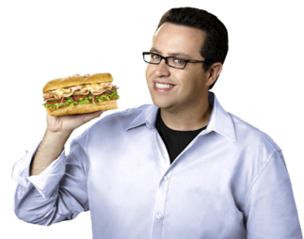

Virginia Amateur Sports, INC

711 5th Street NE, Suite C
Roanoke, Virginia 24016
Telephone: (540) 343-0987
----------------
www.CommonwealthGames.org

FOR IMMEDIATE RELEASE Date: July 14, 2014
Contact: Charity E. Waldron
Director of Operations
(540) 343-0987

Jared Fogle, known as the Subway guy, is coming to Roanoke
Jared will be speaking at to the Boys and Girls Club as part of the Subway Commonwealth Games.

Jared Fogle will be the coming to Roanoke to help kick off the 2014 Subway Commonwealth Games of Virginia. Jared is a spokesman employed by Subway. He is a known icon throughout America as the man who lost over 200 pounds by eating Subway sandwiches. Jared has spoken all over the country to adults and children about healthy dieting and exercise.

Jared will make several appearances in the Roanoke Valley including a visit to the Boys and Girls Club of Roanoke - 1714 9th Street SE Roanoke, Virginia. This event will take place on Thursday July 17th from 1:00-2:00P.M. Jared visits various Boys and Girls Clubs often and will be spending his time talking to children about health and fitness. The mayor’s office will be at the event to recognize and thank Jared for being a part of the Commonwealth Games and the Roanoke Valley.

Laurie Gibbons of the Boys & Girls Clubs of Southwest Virginia said “It is our pleasure to welcome Jared Fogle, the “Subway Guy”, to speak to our Boys & Girls Clubs members about good nutrition, regular physical activity and overall well-being. Jared’s message and that of Virginia Amateur Sports emulate one of our three priority outcomes, Healthy Lifestyle.”

The Subway Commonwealth Games is celebrating its 25th Anniversary with nearly 60 sports held in Roanoke, Salem, Botetourt, New River Valley and statewide. The Games have a local annual economic impact of close to $3.2 million dollars. The Subway Commonwealth Games is open to Virginia residents of all ages and abilities. This event hopes to attract 10,000 athletes this year.

Go online now to register and to receive the full details of the Subway Commonwealth Games at:
www.CommonwealthGames.org
###

